ADOPTED - JUNE 12, 2018
AGENDA ITEM NO. 21
Introduced by the Human Services and Finance Committees of the:

INGHAM COUNTY BOARD OF COMMISSIONERS

RESOLUTION TO APPROVE THE APPLICATION FORM, SCORING CRITERIA FOR THE TRAILS AND PARKS MILLAGE, AND DECLARING A FOURTH ROUND OF APPLICATIONS FOR THE TRAILS AND PARKS MILLAGE

RESOLUTION # 18 – 257

WHEREAS, in November 2014, the electorate approved a countywide trails and parks millage levy of 50/100 (.50) of one mill to be used for the purpose of creating and maintaining a county system of recreational trails and adjacent parks trail system, which may incorporate trails or parks created by local units of government, including Lansing’s River Trail, and may acquire rights of way to connect and extend existing trails; and

WHEREAS, the Park Commission reviewed and edited the Application and Scoring Criteria forms and has developed the following attachments for approval by the Board of Commissioners; and

WHEREAS, the Application shown in Attachment A reflects changes outlining the separate scoring of small communities and including the instruction that the awarded communities need to reference BOC Resolution #18-504 for design standards; and

WHEREAS, the Scoring Criteria shown in Attachment B has been edited to allow the percentage of match to be weighted more heavily, allows the County to recognize if the project is one of the County Trail Priorities as well as recognizing project complexities, lengthiness, and partnership support.

THEREFORE BE IT RESOLVED, the Ingham County Board of Commissioners adopts the recommended application edits for Trails and Parks Millage funding (attachment A) with the changes outlined above.

BE IT FURTHER RESOLVED, that the Ingham County Board of Commissioners adopts the scoring criteria for use by Park Commission and staff for scoring applications for funding (attachment B) with the changes outlined above.

BE IT FURTHER RESOLVED, that a fourth round of applications will be taken beginning June 18, 2018 that will address new construction as identified as regional priority corridors in figure 24 of the Mannik & Smith Trails and Parks Comprehensive Report, and special projects (including blue ways) as well as repairs, rehabilitation, and long-term maintenance projects.

BE IT FURTHER RESOLVED, that application forms will be reviewed and approved by the Board of Commissioners prior to the fifth round.

HUMAN SERVICES: Yeas: Banas, Sebolt, Nolan, Koenig, Louney, Naeyaert
Nays: Tennis Absent: None Approved 06/04/2018

FINANCE: Yeas: Grebner, Crenshaw, Tennis, Koenig, Schafer
Nays: None Absent: Anthony, Louney Approved 06/06/2018

Exhibit A:
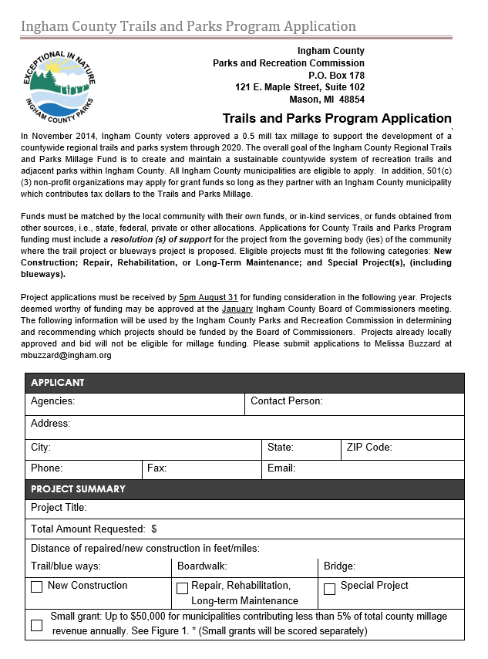

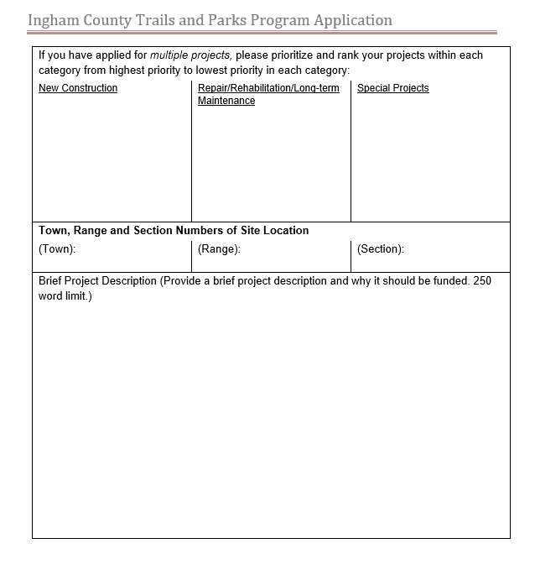

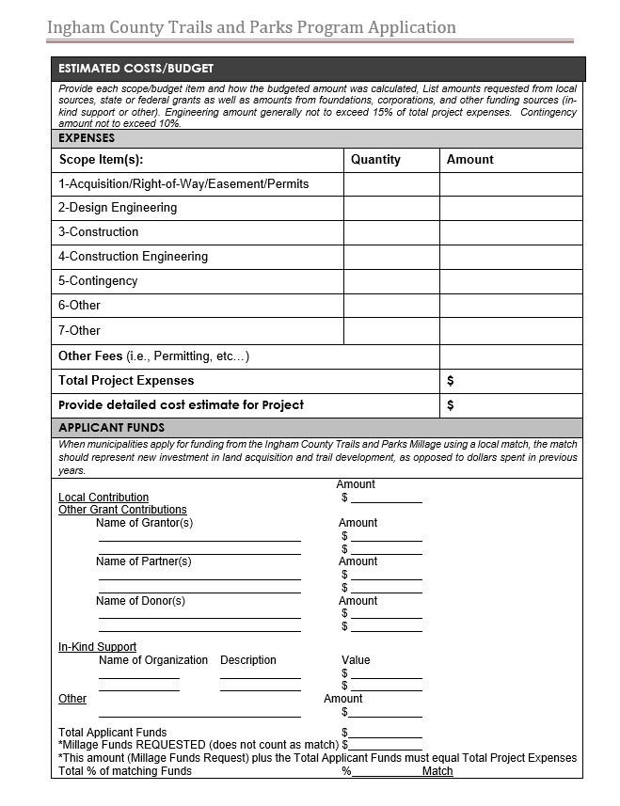
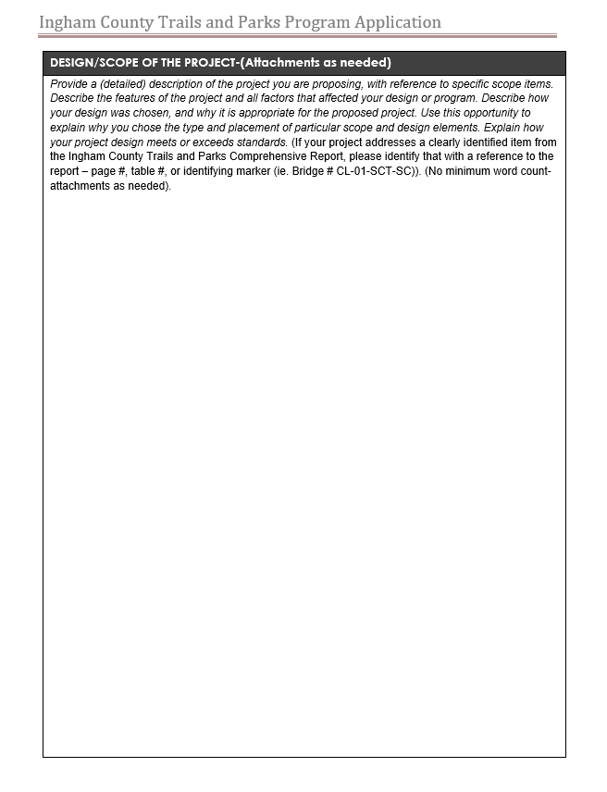

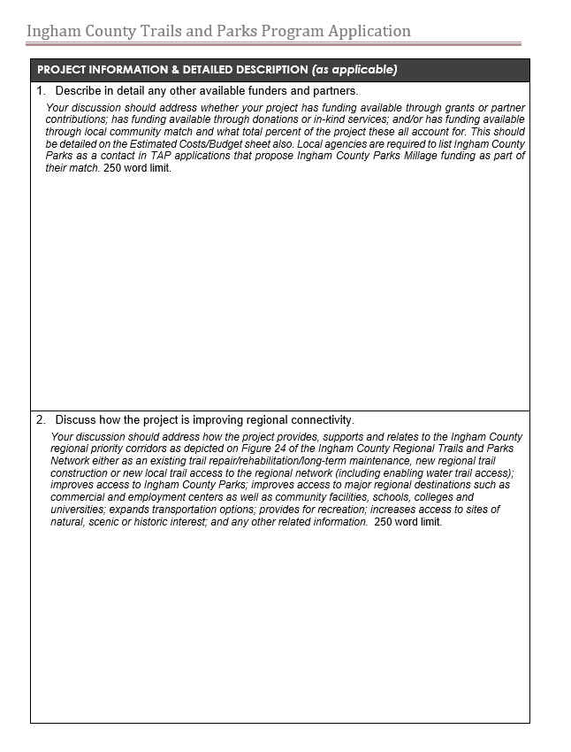
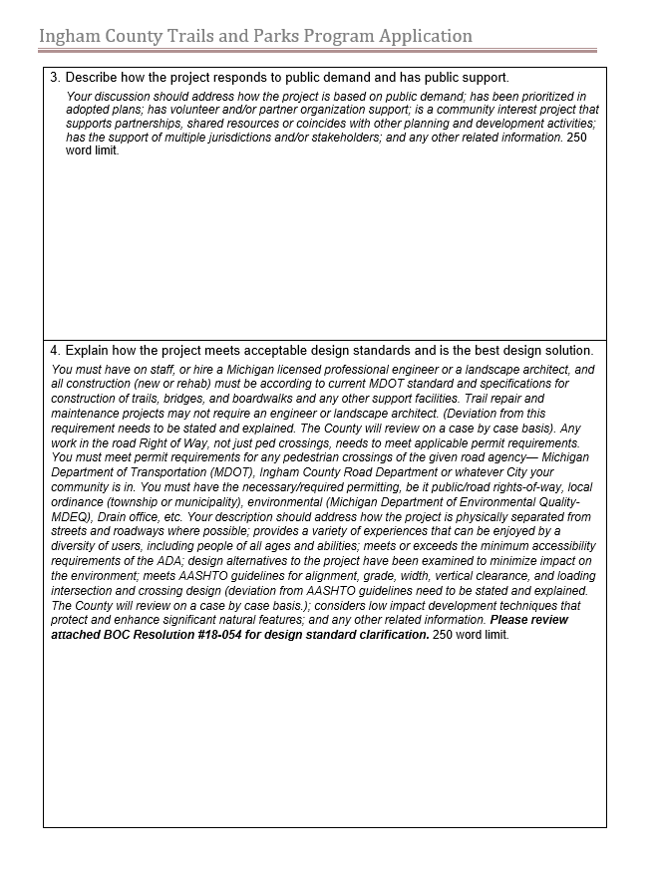
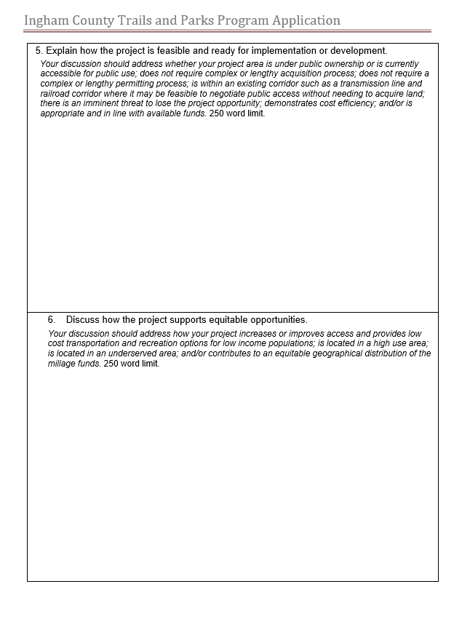
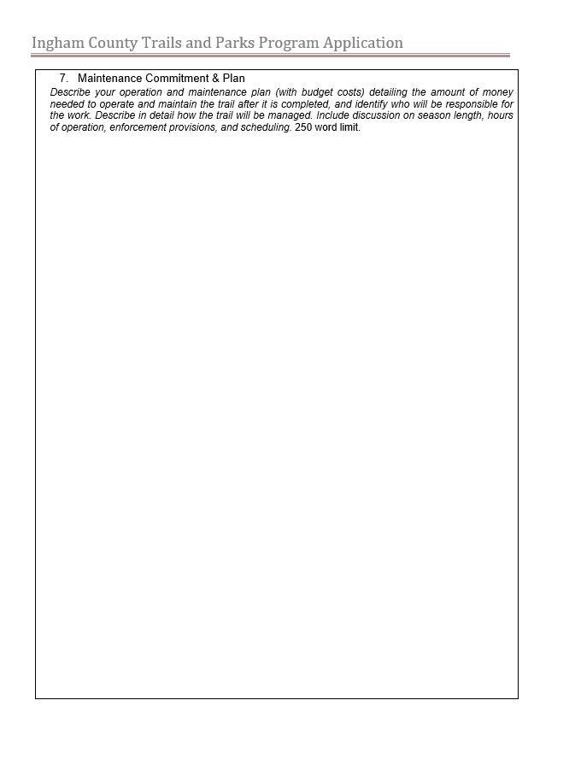

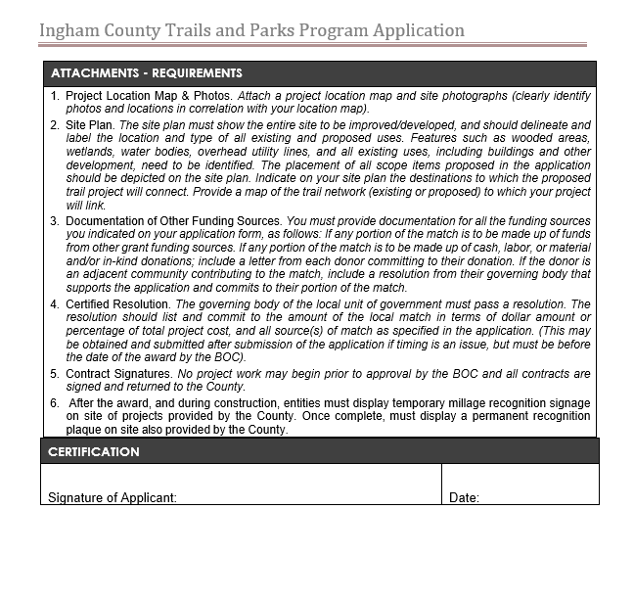

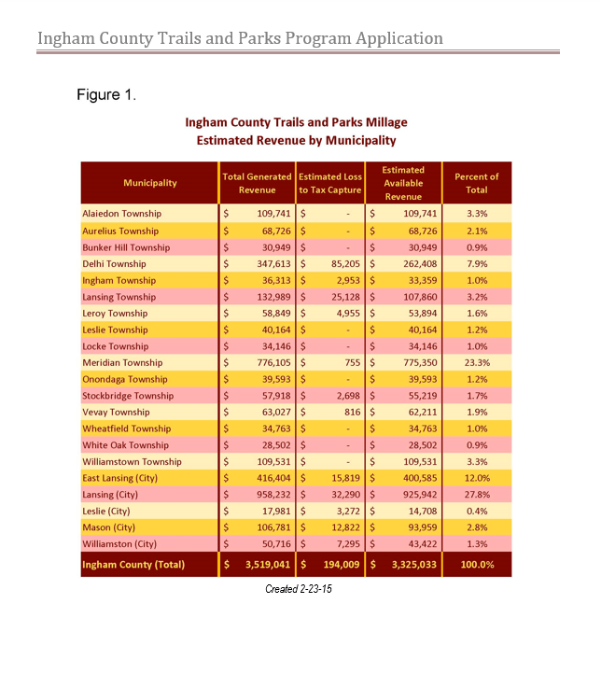

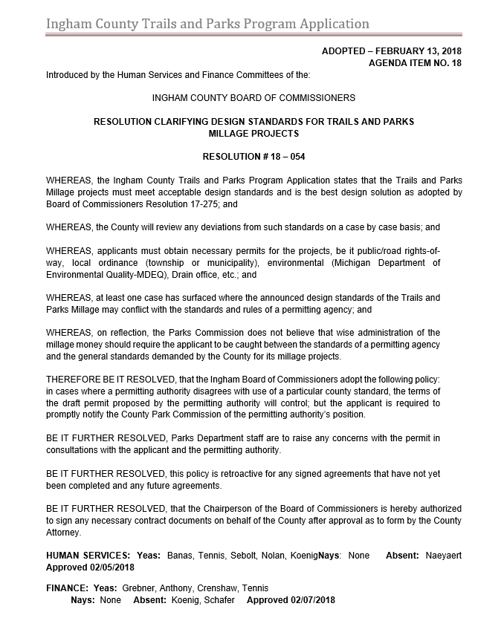
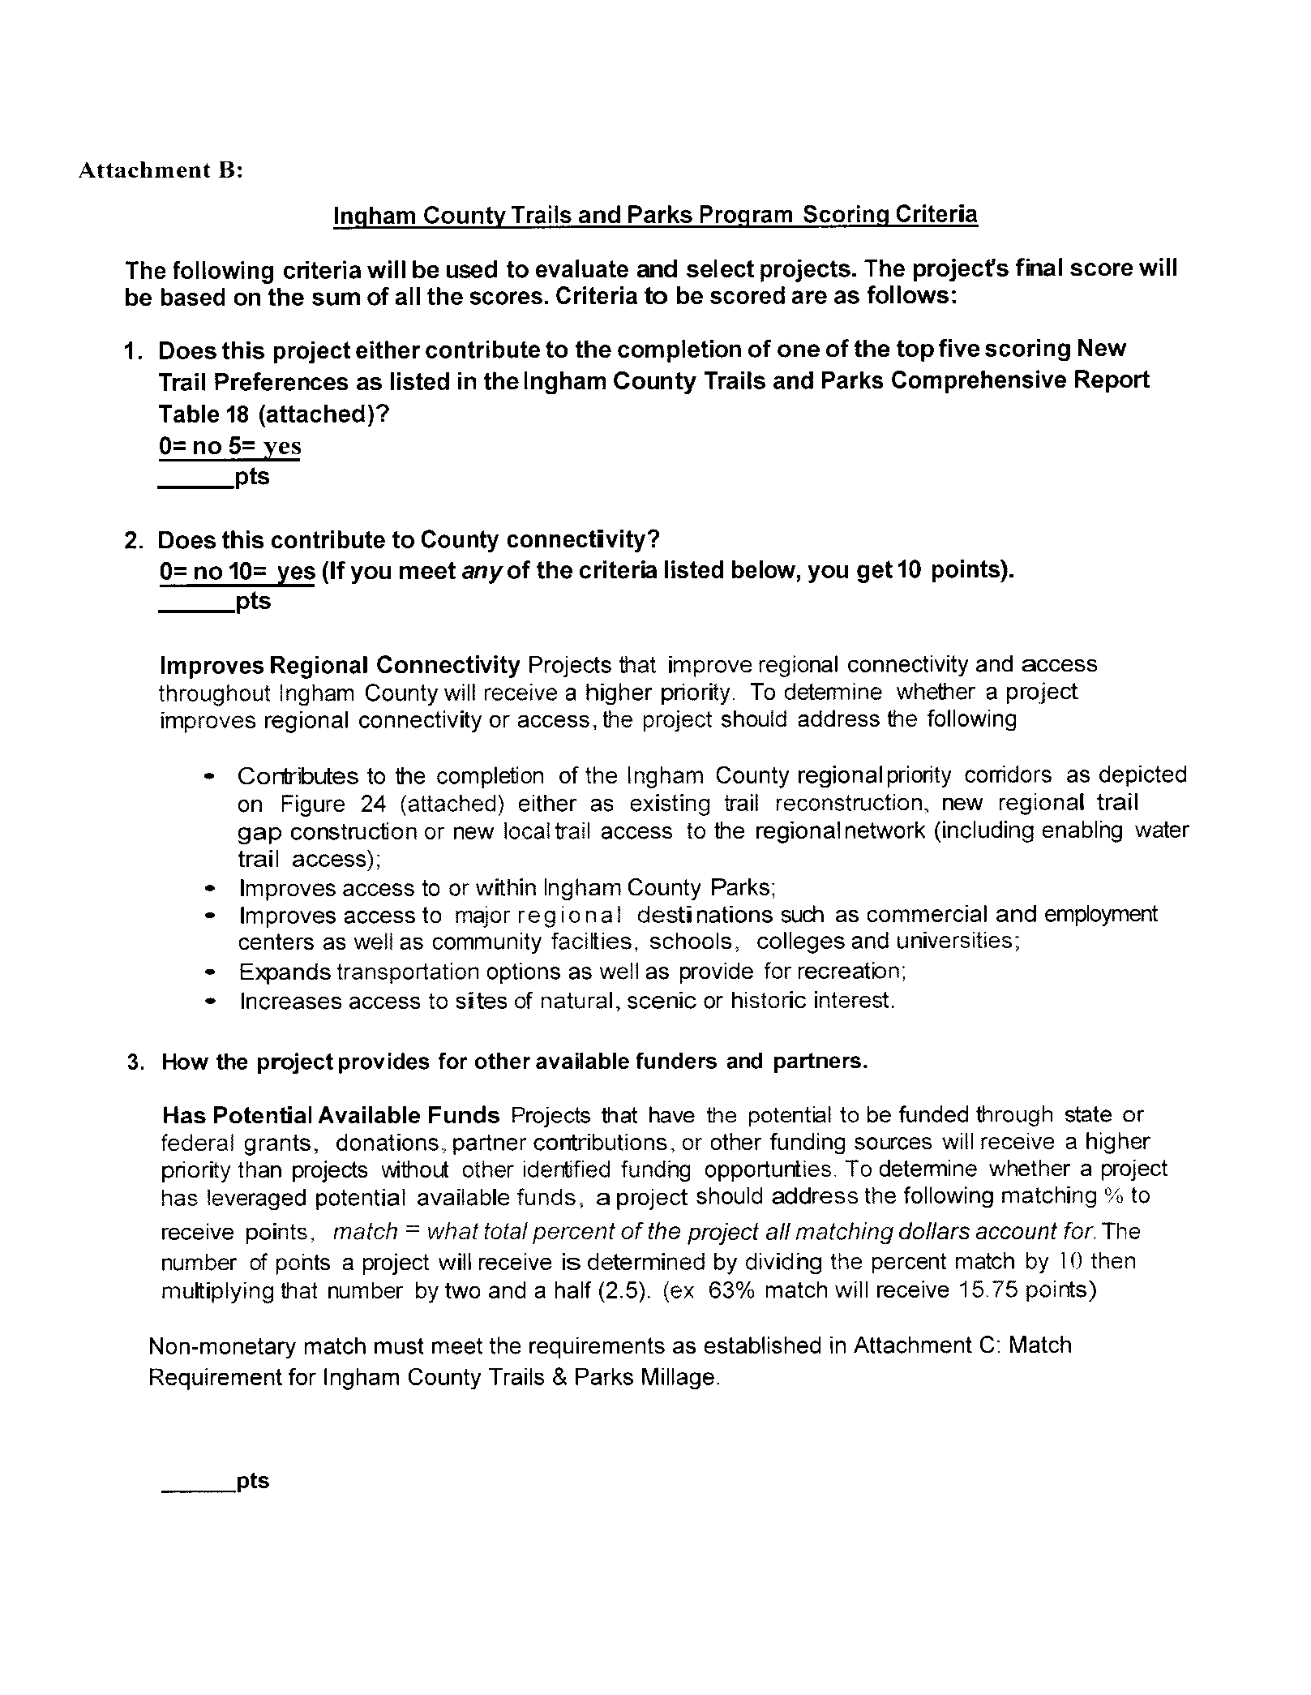
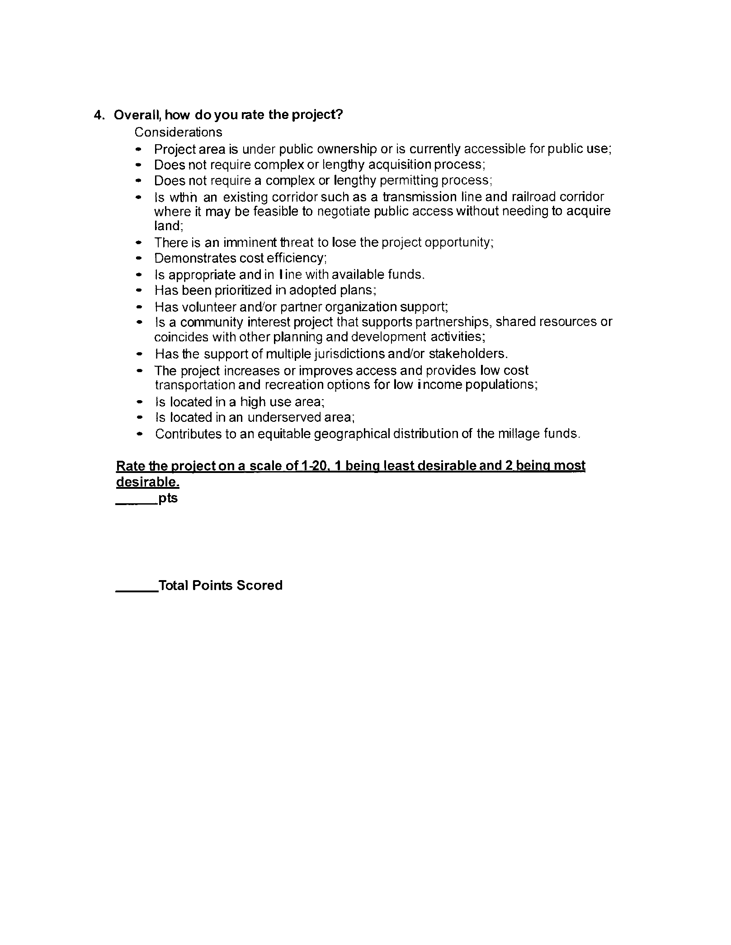

Attachment C

Match Requirement for Ingham County Trails & Parks Millage
The applicant is not required to provide match, however, applicants that do contribute match will receive additional points under the Scoring Criteria. Match being the applicant provided a portion of the total project cost.
Applicant match can be met by general funds, cash donations, and other grants or by donation of a portion of land that will be used for the project. All land value donations must be clearly documented in the grant application and supported by a letter of commitment by the landowner.
Additional forms of match may consist of credit for certain applicant-assumed costs directly related to the construction of the proposed project, including charged for local government-owned equipment and labor performed by the applicant’s employees. Donations of goods and services may be used as all or part of the match if the applicant specifies the nature and can document actual values of the items or services. The source and amount of ALL donations must be clearly stated in the grant application and supported by a letter of commitment from the donor.
Match commitments must be secured prior to the application deadline for that current application round. Proof of secured match must be provided to the County grant coordinator on or before the deadline. Applications using millage funds as match for Federal or State grants will be reviewed on a case by case basis. Failure to provide match documentation by the application deadline may be declared ineligible.
Examples of secured match include:
- General fund-Resolution from local governing body committing to the match
- Cash donations- Letters of commitment from donors
- Other awarded grants- Letter from granting organization committing to the grant, explaining conditions of award, and information on the scope of work provided by the other grant. Applications for other grants are not considered a secure match source
- Donation of land value- Letter from land owner committing to donate a fixed percentage of the appraised fair market value.
- Donation of goods and services- Letter from the donor explaining the nature and value of the goods and services. The letter of donation must indicate number of hours or quantity of materials. The letter must include the quantity, dollar amount and for labor the number of hours and hourly rate. Pre-bid discounts such as percentage off a price are not accepted for documentation of match.
- In-kind/Force-account- Resolution from the governing body committing to the match
Secured match ensures there should not be a cash flow problems threatening the completion of the project. Changing match after the application deadline is highly discouraged and will require approval by the County and the grantee must provide documentation for this change.

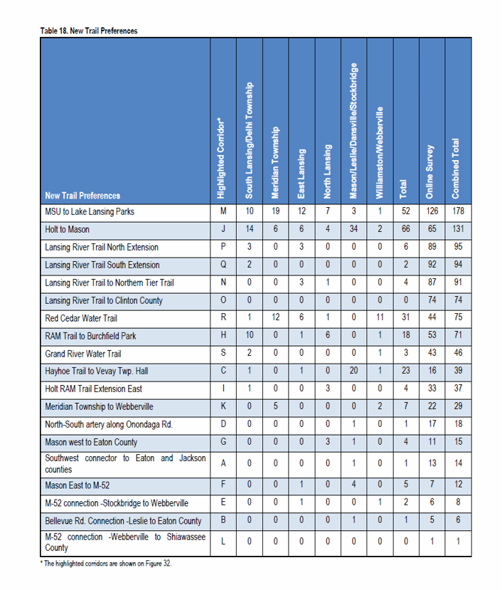

Figure 24

